Basic Overview

Of

Common Chess Openings

By Matt Goddard

Table of Contents

Table of Contents 2
Introduction 3
Chess Notation 3
King’s Pawn Games 5
King’s Gambit 6
Ruy Lopez 7
Guico Piano 8
Scotch Game 9
Four Knights’ Game 10
Petroff Defense 11
Sicilian Defense 12
French Defense 13
Caro-Kann Defense 14
Alekhine’s Defense 15
Queen’s Pawn Games 16
Queen’s Gambit 17
King’s Indian Defense 18
Grünfeld Defense 19
Nimzo-Indian Defense 20
Queen’s Indian Defense 21
Bogo-Indian Defense 22
The Dutch Defense 23
Other Openings 24
English Opening 25
Reti Opening 26
Conclusion 27

Introduction

In any area of interest, it is useful to have names for things, appropriate and consistent names, so that the things can be easily recognized and discussed with other people. In chess, most of the opening moves have been categorized and named. This pamphlet points out the more common chess openings, so that you might recognize them when you’re playing them. A few sample lines are given for each of these major openings, to provide some sense of how play might be conducted. In chess, each time it’s your turn to move, you have the power to guide the position toward openings that suit your temperament.

Chess Notation
The two most common ways of writing chess moves are descriptive notation and algebraic notation. For the most part, I will use descriptive notation in this pamphlet, though it’s useful to acquaint yourself with both forms.

Descriptive Notation
The older form of notation, descriptive, derives from an even older practice of describing the move literally, such as “White moves his king’s knight to the king’s bishop three square,” which was then written KN-KB3. Each player recorded the moves from his own perspective, so White’s QR2 square (at the left-side of the board, the second square up) was also Black’s QR7 square. The word “Castles” was eventually replaced by the symbol “O-O” and “Castles Queenside” was replaced by “O-O-O.” Since "K" is used for the king, "N" or “Kt” is used to indicate a knight. Captures were at one point indicated with the word “takes,” as in “Kt takes Kt,” but this longhand was soon replaced with an "x," such as “Kt x Kt” or “N x N.” Giving check was at one point indicated with the word “check” after a move, but now we’ll use a "+" (plus sign) to indicate “check.” Also, instead of writing “en passant,” we will use the abbreviation “e.p.” whenever a pawn makes that odd capture.

Each move has a turn for White, and a turn for Black. To indicate that each player, on his first move, has moved his king’s pawn up two squares, we would write: 1. P-K4, P-K4

Algebraic Notation
In algebraic notation, the squares are always recorded from White’s point of view. From the White side of the board, the files (vertical) are lettered “a” through “h” from left to right. The ranks (horizontal) are “1” through “8” from the front to the back. Moves such as “Ra8” means “move a rook to the square a8,” which is in the top, leftmost corner. If no letter is given for the piece being moved—such as "d4"—it indicates that a pawn is being moved. As an example, "gxh6" means that a pawn (that was originally in the g file) captures whatever is sitting in the h6 square. There are cases where additional information might be required, such as when two knights could move to the same square; to clarify that we want to move the knight from the g-file, we would write “Nge2.”

Chess notation just takes a little practice. If it seems confusing, you can look to just about any chess book for descriptions that are better than the ones I’ve provided you.
Objectives in the Opening
The player with the white pieces has a slight advantage, since the first move provides the initiative for an attack. At the very least, White should try to preserve his initiative in the opening, so as to reach a favorable middle game where he can continue his attack. The player with the black pieces will try to overcome the burden of being a step behind, since the lack of initiative can leave some pieces without adequate room to maneuver. If Black is able to solve her “problems” in the opening, she has equalized and may even assume the initiative.

Each move in the opening—and throughout the game—should be played to improve the relative position of your pieces, so that the final objective, checkmate, might be reached. Your position may improve in force if you capture one of your opponent’s pieces and thereby enlist a larger army for your command. An advantage in force can bring a quick victory, but often it is persistent, lasting throughout a long, careful struggle and bringing success only after an endgame is reached. An advantage in space may also be long lasting: the position of the pawns on the board defines the terrain in which your pieces operate, and that terrain may be unstable like snowy mountainside or fixed so that ground-shifting captures are impossible. The opening is played to improve force and space, but you may also seek an advantage in time. With extra time to bring your pieces into the attack, you may overwhelm your opponent. Lacking time, you may not be able to call pieces to your king’s defense. As a measurement, a tempo is the time it takes to make a single move; if you move a knight forward, for instance, and then back where it came from, you may have wasted two tempi. Though an advantage in time can slip away as quickly as it appeared, there are openings (gambits) where pawns are sacrificed in order to mobilize pieces and accelerate an attack. In such cases, the player is betting that the disadvantage in force will be offset by advantages in space and time.

Though each position must be evaluated on its own merits, there are some basic guidelines for conducting the openings:

- Control at least your share of the center (that is, the four center squares).
- Develop your knights and your bishops to effective squares.
- Castle your king to safety.

After these objectives are reached, look to:

- Secure unstable terrain (i.e., pawns), where sudden shifts would be dangerous.
- Double your rooks in open (or semi-open) files.
- Identify weaknesses in your opponent’s camp, or your own.

As we look at the selected openings, keep in mind that lines of play initiated by White are generally termed “openings” while reactions by Black are termed “defenses.”

King’s Pawn Games
Moving the King’s pawn forward two squares is the most common way of starting a chess game, and there is no better way to do so. Immediately, you are controlling part of the center by occupying the K4 square and attacking the Q5 square. You are gaining space by freeing your king’s bishop. The most common reaction for Black is to also move his king’s pawn forward two spaces, for the very same reasons.

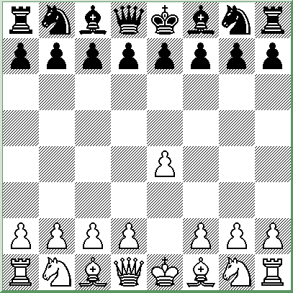
Descriptive Notation
- P-K4

Algebraic Notation
- e4

King’s pawn games tend to lead to lively games with open terrains, where attacking players can quickly get their pieces into the fray.

King’s Gambit
The King’s Gambit is a daring opening that was very popular during the “romantic” period of chess, hundreds of years ago. Players then were quite eager to give up a pawn (or two or three pawns!) to speed up their attack. Nowadays, with defenses so much improved, Grandmasters generally look for less-risky ways to maintain their initiative. Nevertheless, the King’s Gambit will still provide plenty of opportunities for an attacking player. The basic idea is to open up the king’s bishop’s file and launch an attack against the KB7 square. Black can accept the gambit, or decline it; in either case, White’s king may find himself over-exposed!

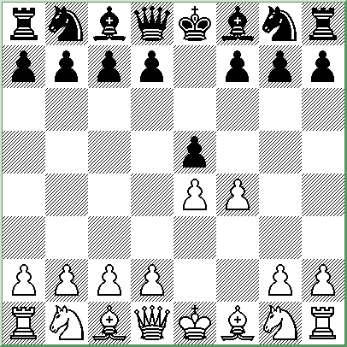

Descriptive Notation
- P-K4, P-K4
- P-KB4

Algebraic Notation
- e4, e5
- f4

King’s Gambit Accepted
After 2. … PxP, White can try 3. B-B4, 3. B-K2, 3. Q-B3, or 3. N-QB3, but has to watch out for counterattacks after Black plays 3. … P-Q4. White’s best try is probably 3. N-KB3, when Black can reply 3. … P-Q4, 3. … N-KB3, 3. … B-K2, 3. … P-Q3 (Fischer’s “bust” to the King’s Gambit), or 3. … P-KN4.

Example: 3. N-KB3, P-Q4; 4. PxP, N-KB3; 5. B-N5+, P-B3; 6. PxP, PxP; 7. B-B4 with a wild and crazy game.

King’s Gambit Declined
Black can decline the gambit and play 2. … B-B4, 2. … P-Q3, or can even offer a counter gambit with 2. … P-Q4. The opening requires careful play from both sides.

Ruy Lopez
A very old opening, the Ruy Lopez (or the Spanish Game) remains extremely popular today. First, White develops a knight (in general, it’s better to get knights out before bishops, since their best posts are usually at KB3 or QB3). Then, Black develops a knight and protects her King’s pawn. With White’s third move, he threatens to win a pawn after BxN.

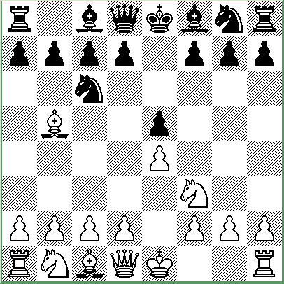

Descriptive Notation
- P-K4, P-K4
- N-KB3, N-QB3
- B-N5

Algebraic Notation
- e4, e5
- Nf3, Nf6
- Bb5

Black can respond with 3. … N-KB3 (the Berlin Defense), 3. … P-Q3 (the Steinitz Defense), 3. … KN-K2 (the Cozio Defense), or 3. … N-Q5 (Bird’s Defense), all of which lead to exciting games.

Black’s most common response to the Ruy Lopez, however, is Morphy’s 3. … P-QR3, attacking the bishop. White can then capture the knight (though this exchange will probably lead to further simplification such as 4. BxN, QPxB; 5. P-Q4, PxP; 6. QxP, QxQ) or retreat the bishop to the a4 square.

Example: 3. … P-QR3; 4. B-R4, P-Q3 (the Steinitz Defense Deferred); 5. P-QB3, B-Q2;
6. P-Q4, KN-K2; 7. O-O and Black’s position is a little cramped.

Guico Piano
The oldest known opening, the “Quite Game” (or Italian Game) points a bishop at Black’s weakest square (her KB2 square). White can lead the contest toward violent clashes or positional struggles, by opening up the center pawns (P-B3 followed by P-Q4) or keeping them closed (P-Q3, and only later P-Q4).

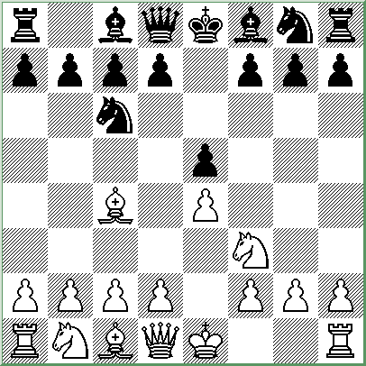

Descriptive Notation
- P-K4, P-K4
- N-KB3, N-QB3
- B-B4

Algebraic Notation
- e4, e5
- Nf3, Nc6
- Bc4

Black can respond with 3. … N-B3 (the Two Knights’ Defense) but has to be ready for the attacks 4. N-N5, or 4. P-Q4 (the Max Lange Attack).

Example: 4. N-N5, P-Q4; 5. PxP, N-QR4; 6. B-N5+, P-B3; 7. PxP, PxP; 8. B-K2 where White is up a pawn but Black has the initiative.

The classical defense is 3. … B-B4, where White may continue with 4. P-B3 and 5. P-Q4, looking to open up the center, castle quickly, and put pressure on Black’s king. White can also sacrifice a pawn with 4. P-QN4 (the Evans Gambit) in order to save a tempo after 4. … BxP; 5. P-B3, B-B4; 6. P-Q4, racing to put pressure on Black before she’s had a chance to castle.

Example: 4. P-B3, N-B3; 5. P-Q4, PxP; 6. PxP, B-N5+; 7. N-B3, NxKP; 8. O-O, BxN; 9. P-Q5 (the Möller Attack).

A more cautious approach for White is to play 4. P-QB3 and 5. P-Q3, protecting his King’s pawn.

Scotch Game
The Scotch Game provides an interesting alternative to the Ruy Lopez and Guico Piano, although Black may be able to free his game earlier.

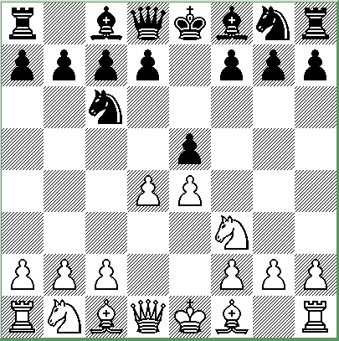

Descriptive Notation
- P-K4, P-K4
- N-KB3, N-QB3
- P-Q4

Algebraic Notation
- e4, e5
- Nf3, Nc6
- d4

The game might continue 3. … PxP; 4. NxP, N-B3 where White can continue 5. NxN, or
5. N-QB3 (the Four Knights’ Variation).

After 3. … PxP; 4. NxP, Black could also try 4. … B-B4 with counter pressure, or the risky
4. … Q-R4.

Example: 3. … PxP; 4. NxP, B-B4; 5. NxN, Q-B3; 6. Q-Q2, QPxN with equal chances.

Four Knights’ Game
The Four Knights’ Game has a reputation for being solid, though not terribly enterprising. It’s hard to argue with moves that stick so firmly to opening principles (to develop knights before bishops) and White does, after all, still have the initiative. He can continue with
4. P-Q4 transposing into the Scotch Game, 4. B-B4 with a Guico Piano, or 5. B-N5 which will not quite transpose into a Ruy Lopez since the queen’s bishop’s pawn is blocked.

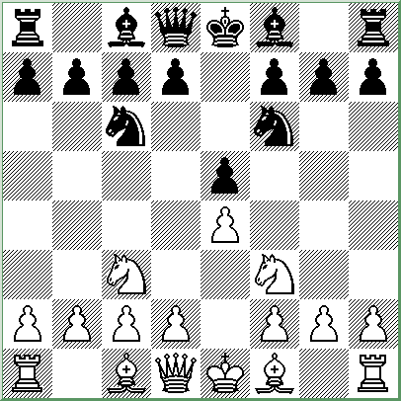

Descriptive Notation
- P-K4, P-K4
- N-KB3, N-QB3
- N-B3, N-B3

Algebraic Notation
- e4, e5
- Nf3, Nc6
- Nc3, Nf6

Black can mimic White’s moves for a while, with 4. B-N5, B-N5; 5. O-O, O-O; 6. P-Q3, P-Q3; 7. B-N5, B-N5; 8. N-Q5, N-Q5; 9. NxB, NxB; 10. N-Q5, N-Q5, but eventually she’ll want to try and grab the initiative with something original.

Black could deviate anywhere along the line, for instance: 4. B-N5, P-QR3; 5. BxN, QPxB;
6. NxP, NxP; 7. NxN, Q-Q5 (recovering the piece) and both sides have to play carefully to avoid disaster.

Petroff Defense
The Petroff (or Petrov’s Defense) is considered super-solid, but there are a lot of pitfalls Black can fall into early on. The idea is to meet White’s attack on the king’s pawn with an attack of her own, but Black cannot reply to 3. NxP with 3. … NxP right away, or she would have to face 4. Q-K2, P-Q4; 5. P-Q3, Q-K2; 6. PxP and she’s simply down a pawn.

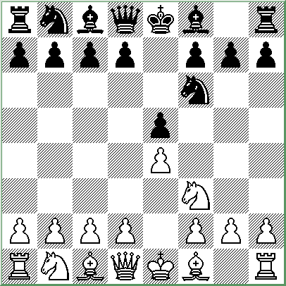

Descriptive Notation
- P-K4, P-K4
- N-KB3, N-KB3

Algebraic Notation
- e4, e5
- Nf3, Nf6

To recover the pawn after 3. NxP, Black would need to play 3. … P-Q3 first, then follows
4. N-KB3, NxP.

White can continue with 5. Q-K2, Q-K2; 6. P-Q3, N-KB3 but Black will have equalized after the exchange of queens. Instead, White might want to continue 5. P-Q4, P-Q4; 6. B-Q3 and Black has to be very careful: for instance, 6. … B-Q3 is now considered a mistake, though it was the standard continuation for a long time. 6. … B-K2 is the preferred move.

White can also play 3. P-Q4 at once, instead of taking the pawn. Play might continue:
3. … PxP; 4. P-K5, N-K5; 5. QxP, P-Q4; 6. PxP e.p., NxP and White still has the initiative.

Sicilian Defense
There are players who avoid king’s pawn openings because of the Sicilian Defense. Here, Black isn’t playing along with the complementary 1. … P-K4, but instead chooses to strike out aggressively on the queenside, hoping to open up the Queen’s bishop file after her opponent plays P-Q4). White can’t just sit by idling, or he will find himself in heavy traffic.

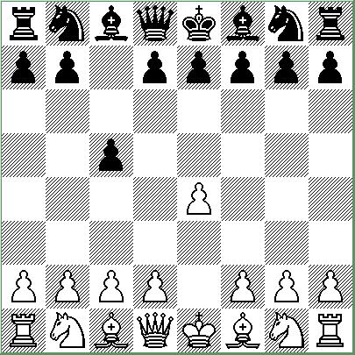

Descriptive Notation
- P-K4, P-QB4

Algebraic Notation
- e4, c5

White’s reply 2. N-KB3 (to prepare 3. P-Q4) leads to an Open Sicilian, and Black has a variety of options, including:

2. … P-Q3, where there might follow:
3. P-Q4, PxP; 4. NxP, N-KB3; 5. N-QB3, P-QR3 (the Najdorf System).
3. P-Q4, PxP; 4. NxP, N-KB3; 5. N-QB3, P-KN3 (the Dragon Variation).
2. … P-K3, where there might follow:
3. P-Q4, PxP; 4. NxP, N-KB3; 5. N-QB3, P-Q3 (the Scheveningen Variation).
3. P-Q4, PxP; 4. NxP, N-KB3; 5. B-N5 (the Sicilian Counter-Attack).
2. … N-QB3, where there might follow:
3. P-Q4, PxP; 4. NxP, N-B3; 5. N-QB3, P-Q3; 6. B-KN5 (the Richter-Rauzer Attack).

White can also head for a Closed Sicilian with 2. N-QB3, 2. N-K2 (the Keres variation),
2. P-QN4 (the Wing Gambit), 2. P-QB3 (the Alapin Variation), or the risky 2. P-Q4 (the Sicilian Center Gambit).

French Defense
The French Defense may seem passive, allowing White to seize the center with 2. P-Q4, but Black intends to play 2. … P-Q4 on the next move, regardless. The resulting position may leave Black’s position cramped for a while (especially developing the queen’s bishop effectively), but she will look to gain space on the queenside with P-QB4, and White may quickly find his forces set to flight.

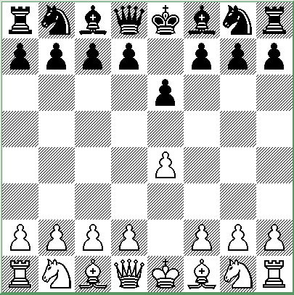

Descriptive Notation
- P-K4, P-K3

Algebraic Notation
- e4, e6

After 2. P-Q4, P-Q4, White can play:

3. PxP (the Exchange Variation), which has the reputation for leading to a lot of draws.
3. P-K5 (the Advance Variation), where Black will respond 3. … P-QB4.
3. N-Q2 (Tarrasch’s Variation), which avoids some of the lines after 3. N-QB3, below.
3. N-QB3, which can lead to:
3. … B-N5 (the Winawer Variation), a very dangerous line.
3. … PxP (Rubinstein’s Variation), which tends to favor White.
3. … N-KB3; 4. P-K5 (the Steinitz Variation), which cramps Black temporarily.
3. … N-KB3; 4. B-KN5, B-N5 (the MacCutcheon Variation).
3. … N-KB3; 4. B-KN5, PxP (Burn’s Variation), followed by 5. NxP, B-K2.
3. … N-KB3; 4. B-KN5, B-K2 (the Classical Variation).

Example: 2. P-Q4, P-Q4; 3. N-QB3 N-KB3; 4. B-KN5, B-K2; 5. P-K5, KN-Q2; 6. BxB, QxB;
7. Q-Q2, O-O; 8. P-B4, P-QB4 with equal chances.

Caro-Kann Defense
The Caro-Kann is similar to the French Defense in that Black’s move prepares an early push of P-Q4, but here she hopes to free her queen’s bishop sooner (since it’s not blocked by a pawn on K3). The resulting positions tend to be safer than those arising from the French defense, but not as double-edged. As a result, the opening has a reputation that ranges from “drawish” to ultra-solid.

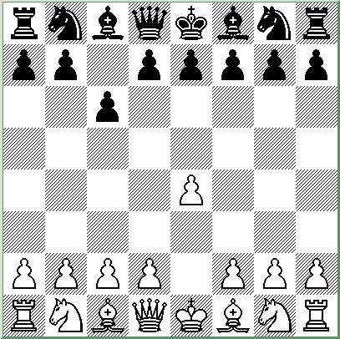

Descriptive Notation
- P-K4, P-QB3

Algebraic Notation
- e4, c6

After 2. P-Q4, P-Q4, White can play:

3. PxP, PxP; 4. P-QB4 (the Panov-Botvinnik Attack), which poses problems for Black.
3. PxP, PxP; 4. B-Q3, a less-forceful Exchange Variation.
3. P-KB3 (the Fantasy Variation), which is considered a bit of a pipe dream.
3. P-K5 (the Advance Variation), where Black will try to free her bishop with 3. … B-B4.
3. N-QB3 (the Main Line), which is generally followed by 3. … PxP; 4. NxP.

Example: 2. P-Q4, P-Q4; 3. N-QB3, PxP; 4. NxP, B-B4; 5. N-N3, B-N3; 6. P-KR4, P-KR3;
7. P-R5, B-R2; 8. N-B3, N-Q2, and both players will be looking to castle queenside.

Alekhine’s Defense
By bringing the king’s knight out, Alekhine’s Defense seems to mock the conventional wisdom of a strong center, occupied with pawns. After 2. P-K5, N-Q4; 3. P-QB4, N-N3; 4. P-Q4, White has established a strong center while Black’s knight has been chased around. The opening champions the idea, however, that center pawns might prove weak and overextended if they can be attacked from the flanks. The idea that the center can be controlled from a distance is the cornerstone of the “hypermodern” school of chess, which gained acceptance in the 1920’s.

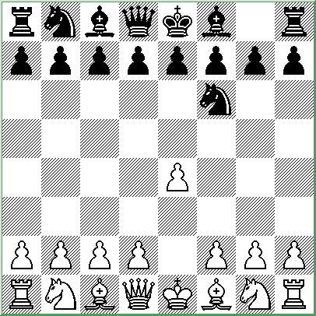

Descriptive Notation
- P-K4, N-KB3

Algebraic Notation
- e4, Nf6

The “Four Pawns Attack” (or Chase Variation) continues 2. P-K5, N-Q4; 3. P-QB4, N-N3;
4. P-Q4, P-Q3, where White can play:

5. P-B4, which could indeed lead to an overextended center after 5. … PxP; 6. BPxP and Black will continue with B-B4 and P-K3. Or,

5. PxP (the Exchange Variation), which shouldn’t cause Black too much trouble.

The “Accelerated Chase Variation” is 2. P-K5, N-Q4; 3. P-QB4, N-N3; 4. P-B5, N-Q4, where White can continue with 5. P-Q4, 5. N-QB3, or 5. B-B4.

The “Modern Variation” is 2. P-K5, N-Q4; 3. P-Q4, P-Q3; 4. N-KB3.

Queen’s Pawn Games
Moving the queen’s pawn forward two squares is the most common alternative to the King’s Pawn Games. Once again, the center is controlled and a bishop is free to move. Black’s traditional response is also P-Q4, for the same reasons—and also to prevent White from playing an immediate P-K4. In most of the lines that follow, White will continue with P-QB4; he may, however, refrain from playing this move early on, instead playing P-QB3 as an “Anti-Indian” strategy.

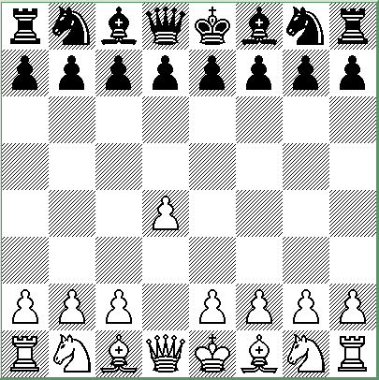

Descriptive Notation
- P-Q4

Algebraic Notation
- d4

Queen’s pawn games tend to lead to conflicts of a more positional nature, where long-range planning and subtle maneuvering is required.

Queen’s Gambit
The Queen’s Gambit is not really a gambit, since (after 2. … PxP) White could play 3. Q-R4+ and 4. QxBP to recover the pawn immediately. There are, in fact, several advantageous ways in which White can recover the pawn, and Black will find herself in trouble if she tries to hold onto it. One of the basic ideas behind the Queen’s Gambit is that White is looking to trade a side pawn for a center pawn, thereby gaining more control of the center. Black can accept the gambit, or decline it.

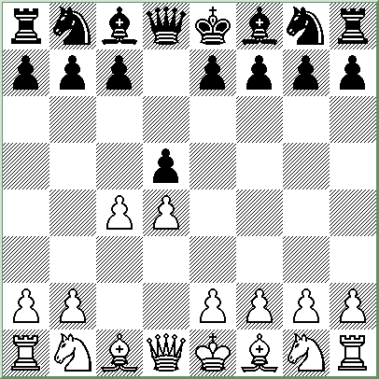

Descriptive Notation
- P-Q4, P-Q4
- P-QB4

Algebraic Notation
- d4, d5
- c4

Queen’s Gambit Accepted
Black plays 2. … PxP knowing that she will not be able to hold onto the extra pawn. If she were to try to hold it, she might face something like: 3. P-K3, P-QN4; 4. P-QR4, P-QB3; 5. PxP, PxP; 6. Q-KB3 with dire results. Or, 3. N-KB3, P-QN4; 4. P-QR4, P-QB3; 5. P-K3, B-N2; 6. PXP, PXP; 7. P-QN3 and White has the advantage. Instead, Black will let White recapture the pawn and aim toward developing normally.

Queen’s Gambit Declined
Black’s will usually decline the gambit with 2. … P-K3 (the Orthodox Defense) or 2. … P-QB3 (the Slav Defense). White can then exchange the pawn with 3. PxP (the Exchange Variation, or Slav Exchange Variation) and maintain a slight advantage—the drawback being that Black is then able to free her queen’s bishop, which would otherwise have trouble finding an adequate post. In order to keep the pressure on, White usually holds off on the exchange.

King’s Indian Defense
The King’s Indian Defense is a fighting, hypermodern defense where Black will fianchetto her King’s bishop (that is, to play P-KN3 and B-N2) and attack White’s center pawns once they are established. By avoiding the Queen’s Gambit, this defense against the Queen’s Pawn Game brought numerous Soviet victories in chess, and was refined further by Bobby Fischer, culminating in his defeat of Boris Spassky in 1972.

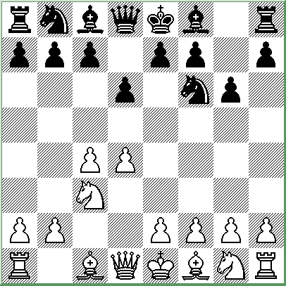

Descriptive Notation
- P-Q4, N-KB3
- P-QB4, P-KN3
- N-QB3, P-Q3

Algebraic Notation
- d4, Nf6
- c4, g6
- Nc3, d6

White will generally play 4. P-K4 and Black will look to eventually make a break with P-K4 or P-QB4. Of course, Black’s king’s bishop is heading for KN2 (in fact, this move is usually played before 3. … P-Q3 to preserve the possibility of a Grünfeld Defense).

The Classical Line is 4. P-K4, B-N2; 5. N-B3, O-O; 6. B-K2, P-K4.

White can play the Four Pawns Attack with 4. P-K4, B-N2; 5. P-B4.

The Sämisch Variation is 4. P-K4, B-N2; 5. P-B3.

In the Fianchetto System, White fianchettos his own king’s bishop.

Example (showing an alternate move order): 1. P-Q4, N-KB3; 2. P-QB4, P-KN3; 3. N-KB3,
B-N2; 4. P-KN3, P-Q3; 4. B-N2, O-O; 5. O-O, N-B3; 6. N-B3, B-B4 with an exciting game.

Grünfeld Defense
The Grünfeld Defense (or Grünfeld-Indian Defense) is similar to the King’s Indian Defense, except that the queen’s pawn is played forward two squares instead of one. The defense produces sharp struggles where White has to be careful or he’ll find himself with a very unstable center.

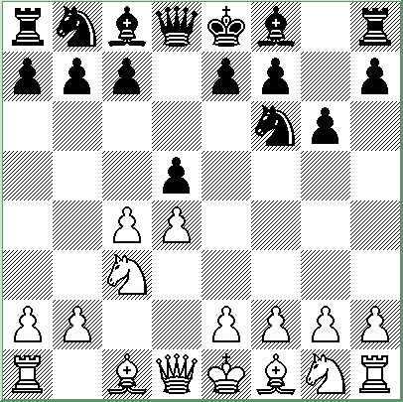

Descriptive Notation
- P-Q4, N-KB3
- P-QB4, P-KN3
- N-QB3, P-Q4

Algebraic Notation
- d4, Nf6
- c4, g6
- Nc3, d5

The Exchange Variation is 4. PxP, NxP; 5. P-K4, NxN; 6. PxN, B-N2, where Black will be looking to play P-QB4 to disrupt White’s strong center.

Example: 7. N-B3, P-QB4; 8. B-K2, N-B3; 9. P-Q5, BxP+; 10. B-Q2, BxR; 11. QxR, N-Q5;
12. NxN, PxN; 13. QxP, O-O; 14. O-O, which is unclear even though White is down material.

The Russian System is 4. Nf3, B-N2; 5. Q-N3 with an entertaining game in store.

Example: 5. … PxP; 6. QxP, O-O; 7. P-K4, N-B3; 8. B-K2, B-N5.

Nimzo-Indian Defense
With the Nimzo-Indian Defense, Black scoffs at White’s initiative and launches a dangerous counterattack. This is now a well-respected defense, and many players choose, as White, to play N-KB3 on the third move instead of bringing out the queen’s knight, in order to avoid the Nimzo-Indian. Black’s idea is to create a weakness in White’s pawn structure after BxN, though White’s doubled pawn will strengthen his center, and he’ll end up with two bishops.

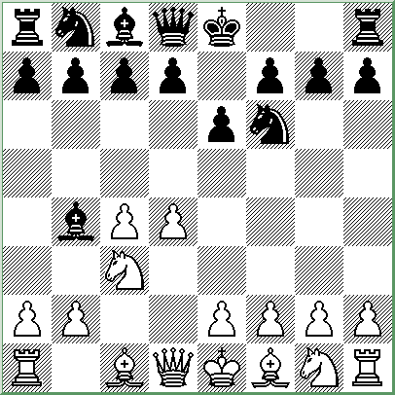

Descriptive Notation
- P-Q4, N-KB3
- P-QB4, P-K3
- N-QB3, B-N5

Algebraic Notation
- d4, Nf6
- c4, e6
- Nc3, Bb4

White has a variety of choices:

4. Q-B2, the Classical Variation, where White plans to recapture with his queen and avoid the doubled pawns.

4. P-K3, the Rubinstein Variation, where White can develop normally or look to play his king’s knight to K2 at some point, in order to recapture with his knight (after Black plays BxN).

4. P-QR3, the Sämisch Variation, where White uses a tempo to force Black to continue with his plan of BxN.

4. Q-N3, the Spielmann Variation, which is similar to the Classical Variation, but hopes to encourage Black to exchange with BxN sooner.

4. B-N5, the Leningrad Variation, which leads to sharp play.

Queen’s Indian Defense
If White plays 3. N-KB3, to avoid the Nimzo-Indian Defense, he may face instead the Queen’s Indian Defense. Here, Black fianchettos her queen’s bishop and hopes to put pressure on White’s kingside along the diagonal. Some players, as White, would rather meet the Nimzo-Indian defense, and will play N-QB3 on the third move, rather than the king’s knight, to avoid the Queen’s Indian.

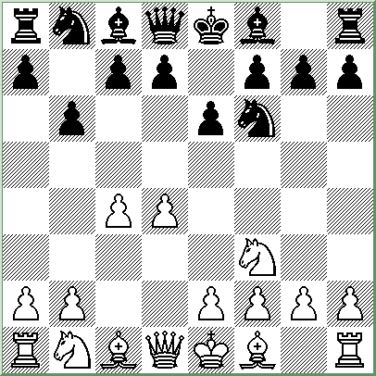

Descriptive Notation
- P-Q4, N-KB3
- P-QB4, P-K3
- N-KB3, P-QN3

Algebraic Notation
- d4, Nf6
- c4, e6
- Nf3, b6

White’s typical reaction is to fianchetto his own king’s bishop with 4. P-KN3, B-N2; 5. B-N2, where Black has a few different choices:

5. … B-K2; 6. O-O, O-O, where White can continue with 7. N-B3, 7. P-Q5, 7. R-K1, 7. Q-B2, or 7. P-N3.

5. … B-N5+; 6. B-Q2 where Black can exchange bishops (similar to a Bogo-Indian defense) or retreat with 6. … B-K2 (Alekhine’s move).

5. … P-B4 or 5. … Q-B1 are also playable.

White can also decide not to fianchetto his king’s bishop and instead try to develop normally with N-B3, B-N5, P-K3, B-Q3, and Q-B2. Black can work toward disrupting this plan with an eventual P-B4 or a well-timed N-K5.

Bogo-Indian Defense
The Bogo-Indian Defense is another option for Black, should White bring out his king’s knight rather than queen’s knight on the third move (it should be mentioned that another option is 3. … P-Q4, transposing into a Queen’s Gambit Declined). The Bogo-Indian often leads to simplification (especially after 4. B-Q2, BxB+) where White maintains a slight advantage, but it can also lead to an intense brawl.

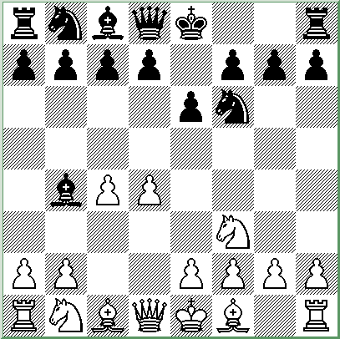

Descriptive Notation
- P-Q4, N-KB3
- P-QB4, P-K3
- N-KB3, B-N5+

Algebraic Notation
- d4, Nf6
- c4, e6
- Nf3, Bb4+

White’s choices are 4. B-Q2, 4. QN-Q2, or 4. N-B3 (transposing into a Nimzo-Indian Defense where the king’s knight is already played).

After 4. B-Q2, Black has several reasonable replies:

4. … BxB+
4. … Q-K2
4. … B-K2
4. … P-QR4
4. … P-QB4

After 4. QN-Q2, Black can continue with such moves as 4. … P-QB4, 4. … O-O, 4. … P-QN3, or 4. … P-Q4.

The Dutch Defense
One way Black can quickly change the texture of the game is with the Dutch Defense. Here, Black answers the Queen’s Pawn Game by advancing her king’s bishop’s pawn, still preventing P-K4 by White and hoping to initiate an attack on the kingside. This aggressive opening may drag White into uncomfortable territory, or it may leave Black with an exposed king.

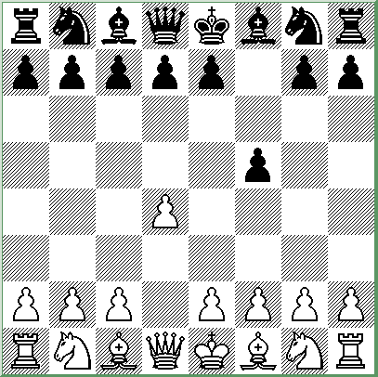

Descriptive Notation
- P-Q4, P-KB4

Algebraic Notation
- d4, f5

White’s primary choices are:

2. P-KN3, the Modern System, where White fianchettos his king’s bishop and thereby reduces Black’s attacking chances on the kingside.

Example: 2. … P-K3; 3. B-N2, N-KB3; 4. N-KB3, B-K2; 5. O-O, O-O; 6. P-B4, P-Q4 (the Stonewall Formation); 7. Q-B2, P-B3, and White will have a hard time breaking through.

2. P-QB4, the Classical System, which shouldn’t cause Black too much trouble.

2. P-K4, the Staunton Gambit, where there might follow 2. … PxP; 3. N-QB3, N-KB3. White is down a pawn but has various attacking plans at his disposal, such as 4. P-B3, 4. P-KN4, or 4. B-KN5.

Other Openings
White can try to avoid heavily analyzed lines by playing an unusual opening, such as the “Nimzowitsch Attack” shown below (a sort of Queen’s Indian Attack). White’s most common “unusual” choices are the English Opening, and the Reti Opening (including the King’s Indian Attack).

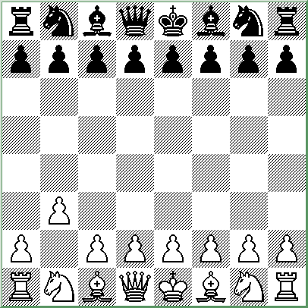

Descriptive Notation
- P-QN3

Algebraic Notation
- b3

The Nimzowitsch Attack (also called the Queen’s Fianchetto Opening) can be safely answered with 1. … P-K4, 1. … N-KB3, 1. … P-QN3, 1. … P-QB4, or 1. … P-Q4.

English Opening
The English Opening is quite respectable. White guards against Black’s P-Q4 and plans to develop his queen’s knight to QB3, behind the pawn. The English Opening is something of a Sicilian Defense in reverse (Sicilian Attack), especially if Black responds with 1. … P-K4. In other circumstances, it may transpose into a different openings, such as the Queen’s Gambit or one of the Indian systems of defense.

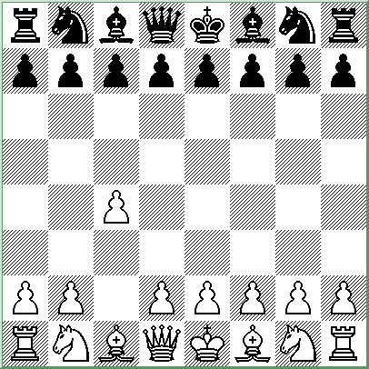

Descriptive Notation
- P-QB4

Algebraic Notation
- c4

The Four Knights’ Variation is 1. … P-K4; 2. N-QB3, N-KB3; 3. N-B3, N-B3 which is a Sicilian with colors reversed. White can try 4. P-Q4, 4. P-K4, or 4. P-KN3.

The Symmetrical Variation might look something like 1. … P-QB4; 2. N-KB3, N-KB3; 3. N-B3, N-B3; 4. P-K3, P-K3; 5. P-Q4, P-Q4; 6. P-QR3, P-QR3; 7. PxBP, BxP, with an equal game, though both sides could have deviated at earlier points.

Black can also play 1. … N-KB3, 1. … P-KB4, 1. … P-KN3, 1. … P-K3, 1. … N-QB3, or 1. … P-QB3, with the game often transposing into a different opening.

Reti Opening
The Reti Opening is a product of the hypermodern school, controlling the center from a distance and preparing to undermine Black’s advancing pawns with moves such as P-QB4. Even from a classical perspective, the opening has its merits: it develops a knight to its most useful square and prevents Black from an immediate 1. … P-K4.

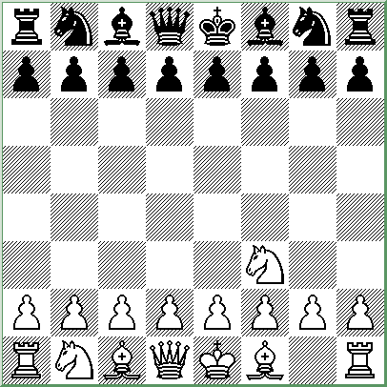

Descriptive Notation
- N-KB3

Algebraic Notation
- Nf3

The “Alfred Wolf” Gambit is 1. … P-Q4; 2. P-B4, where play might continue 2. … PxP;
3. N-R3, P-QB4; 4. NxP, with an unusual situation at hand.

The King’s Indian Attack, which White can pursue after various moves by Black, continues with 2. P-KN3, and 3. B-N2. White might look to continue with O-O, P-Q3, P-K4, and N-B3.

White is also prepared to transpose into other openings if it will prove favorable. For instance, by playing P-Q4 at some point, White can shift the position into a Queen’s Pawn Game of some sort.

If Black is hoping to transpose into a Dutch Defense with 1. … P-KB4, she will have to watch out for the interesting Lisitzin Gambit: 2. P-K4, PxP; 3. N-N5, though the gambit should lead only to equality with best play.

Conclusion

There are many interesting openings that I did not cover in this pamphlet. For a comprehensive look at the many options available, or to see the latest improvements made in chess theory, you may want to purchase a manual of chess openings, such as “Modern Chess Openings.” In the meantime, you should familiarize yourself with the openings I have covered, so that you can at least identify them when you’re playing. You’ll find that chess becomes even more interesting, now that the openings have names.

